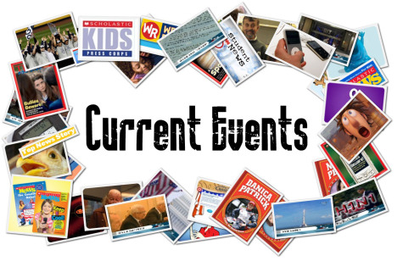
You will be completing a final current event report that will count as a quiz grade for the fourth marking period. Your grade will be based on five different areas that add up to a total of 20 points. Be sure to use these directions, the rubric on the back, and comments from past current event reports to help you!

Your current event report will be graded on the following:

1. Summary
This should be summarized correctly and contain all of the important information from the entire article. Remember: Do NOT copy sentences and change a few words. A summary should tell the reader the important details and information in your own words. Do not choose an article that may be confusing to you. The accuracy of the information will count towards your grade as well.

2. Personal Response
Your sentences should be well-developed in your response. For example, do not write sentences such as “I thought this article was very interesting.” Instead, write “I thought this article was very interesting because….”. Use the questions on the current event template sheet to help you write your personal response.

3. Required Information
ALL sections of the current event report template should be filled out and nothing should be left blank. You must have a MINIMUM of five well-developed sentences for both your summary and personal response.

4. Conventions
Spelling, grammar, and neatness (if you are hand-writing your report) will count! Be sure to read it over before handing in your final copy. Although it is not required, it is suggested that you type your report. You can find the template on my website.

5. Article
You can either 1) print and attach a copy of the article, or 2) copy and paste the link into your report in the “Source” section. This is required so that I can easily refer back to the article when grading your summary. You will lose points if your report is missing the article or link, so don’t forget to include it!

Due Date: Your report will be due by Wednesday, April 18th. You may also hand it in anytime before then as well!

